1. Create one VPC,with 1 one public subnet and 1 private subnet.

**Goto AWS console and search for VPC --🡪Create VPC**

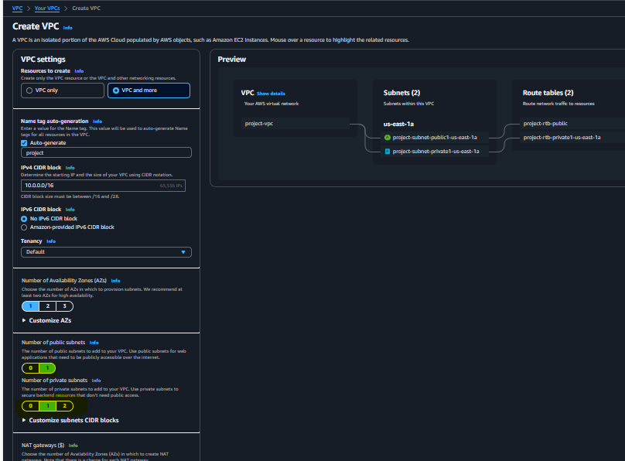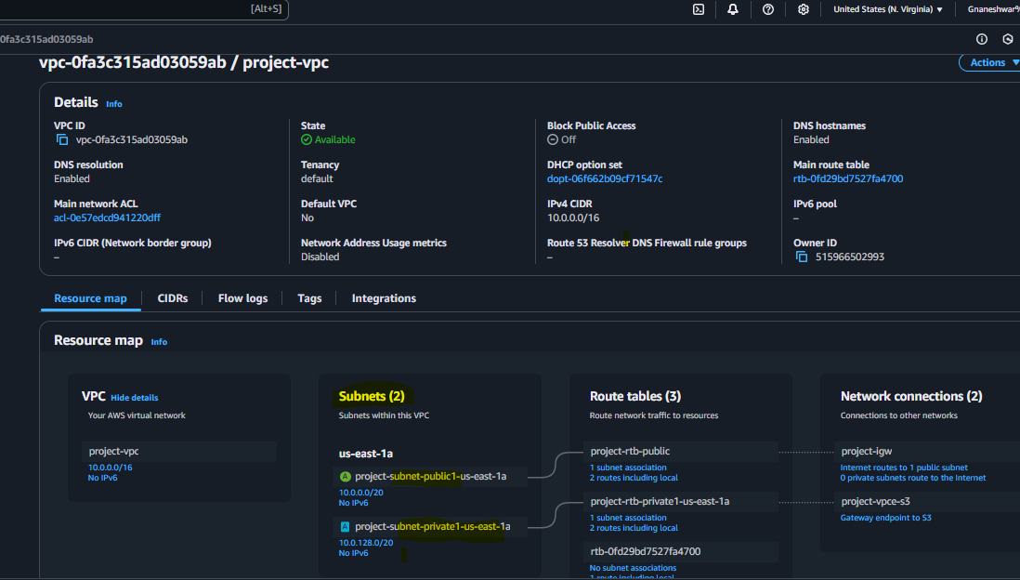

1. Enable VPC peering for cross region.

**First create 2 instances with different VPC’s in one region or different region thenGoto VPC dashboard and Select VPC --**🡪**Peering connections-**🡪**Create Peering**

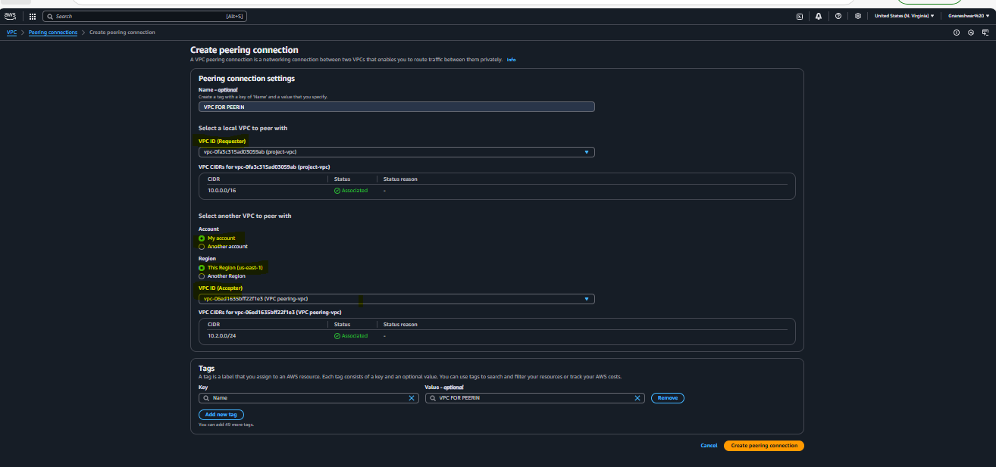**Now goto Acceptor VPC peer and accept the request**

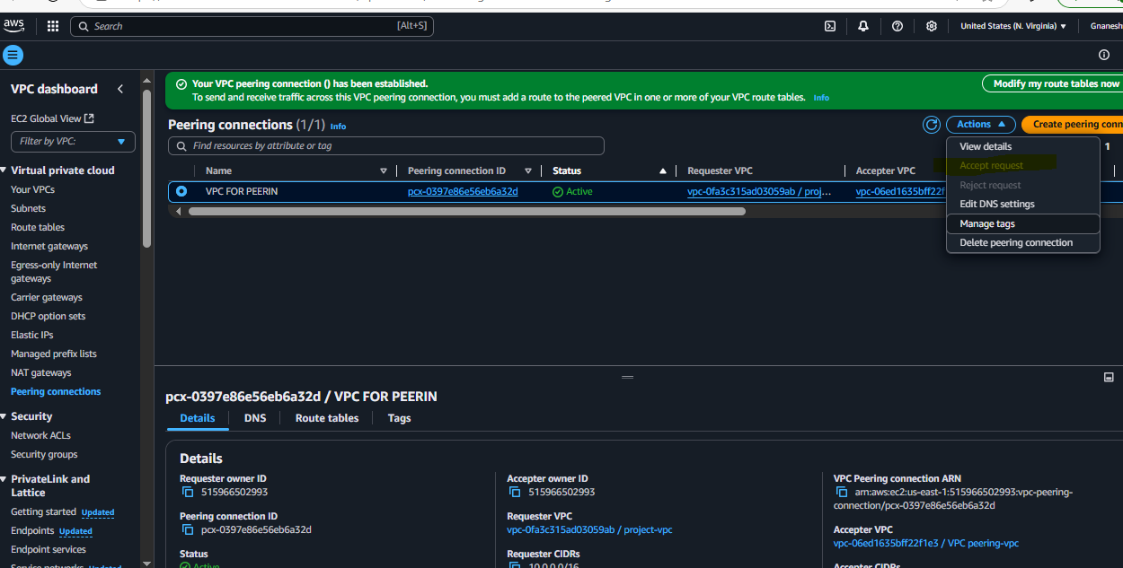

**Now we are able connect to the Private IP of 2nd instance which VPC is different**

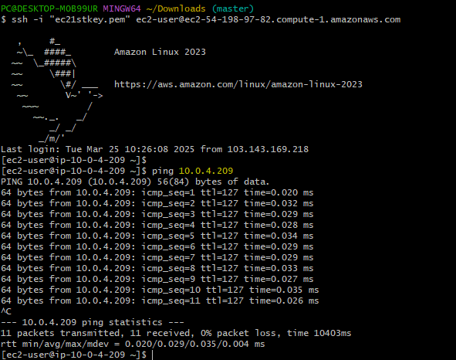

1. Enable VPC peering for cross account. (You can collaborate with your friend and do this task). 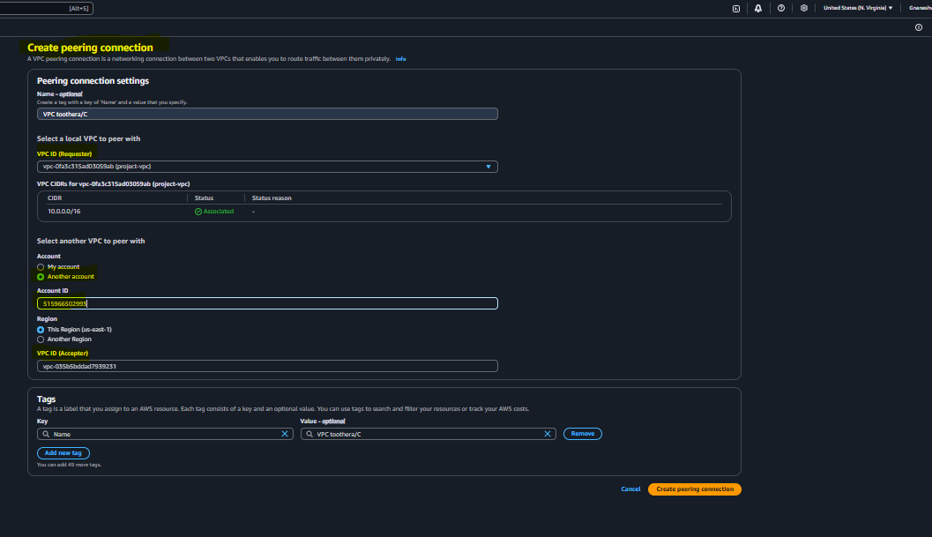



1. Setup VPC Transist gateway.

**Create 4 VPC’s with 4 different CIDR ranges and create 4 subnetss for each VPC**

**Goto Transit Gateway ---🡪Create 1 default Transit gateway**

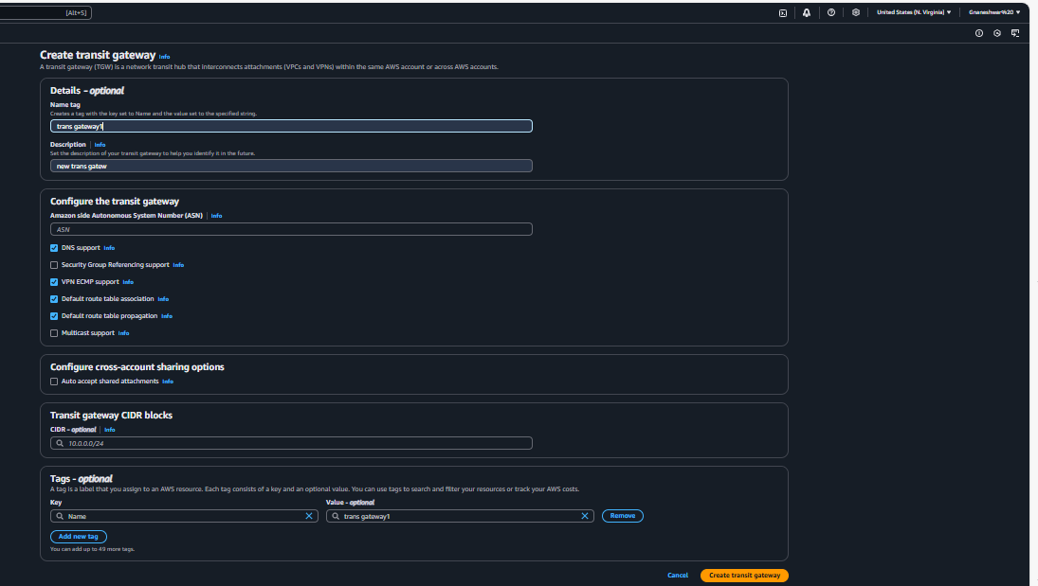

**Now create 4 transit gateway attachments for each VPC**

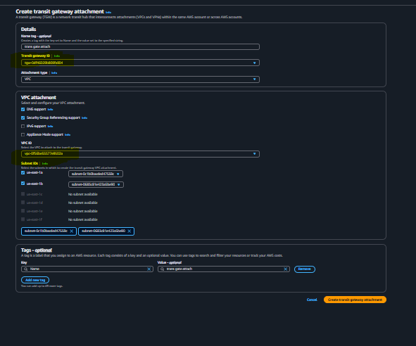

**U can see all the 4 attachments under Transit gateway route tables**

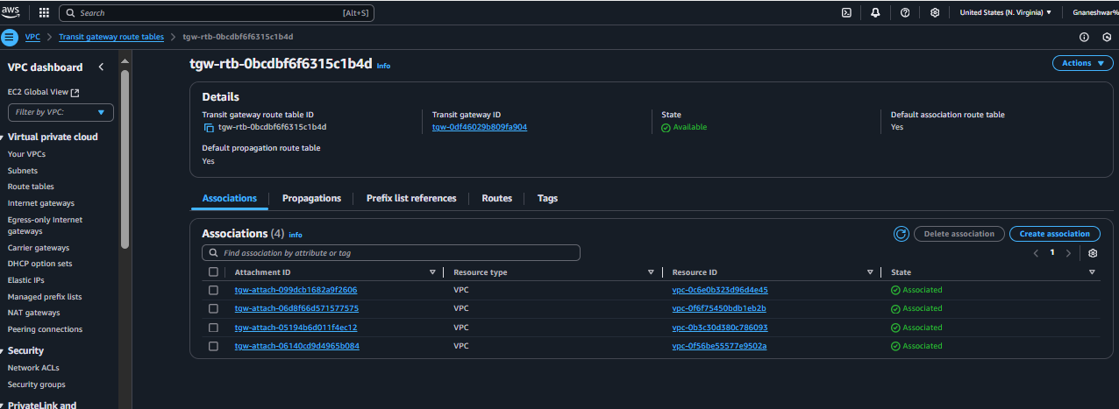

**Launch 4 instances running in 4 different VPC’s after that GOto Routing tables and click on Edit Routes add all remaining VPCs IP ranges ,Transit gate gateway Id and save**

**Similarly do the same process for all Routing tables**

**And create IGW and attch to all VPC’s ,check using ping for all private IP’s**

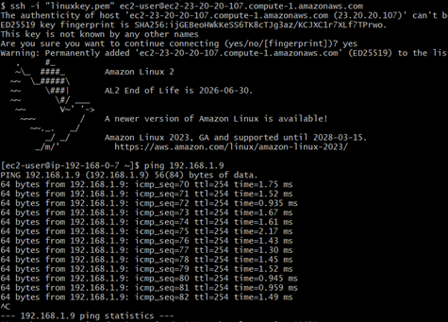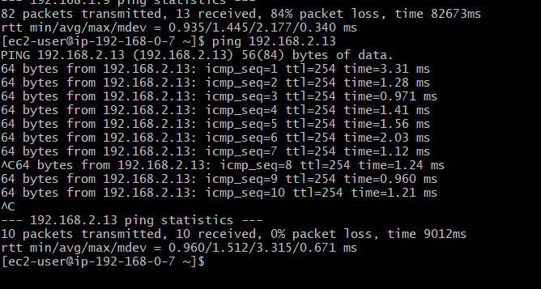

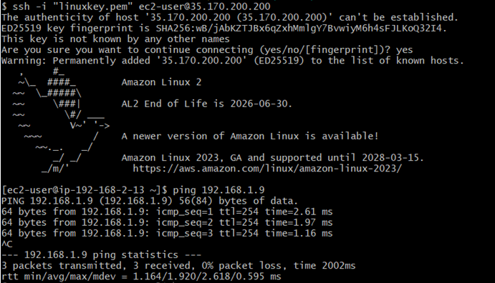

1. Setup VPC End Point.

**Create 1 ec2 instance in public subnet and another instance in Private subnet ,**

**Also a create one S3 bucket to privately access without the internet**

